**EXPERIMENT 6**

**AIM: Working with Docker Compose File to Control Multiple Containers**

**Steps to Complete:**

**Creating compose files**

* Create a directory named nginx in your root.v

mkdir nginx

* Switch to that directory and create a file named docker-compose.yaml

cd nginx

vi docker-compose.yml

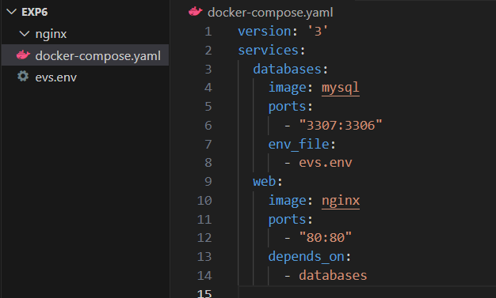

* Use docker-compose version 2 to create docker-compose.yaml file.

Create a service named "databases". Use image named "mysql"

Map container 3306 port to host machine 3306 port.

Add environment variables named "MYSQL_ROOT_PASSWORD", "MYSQL_DATABASE", "MYSQL_USER" and "MYSQL_PASSWORD" along with corresponding values for all.

cat evs.env

MYSQL_ROOT_PASSWORD=redhat08

MYSQL_DATABASE=nginxdb

MYSQL_USER=root  
  
 Add another service named "web"

Use image "nginx"

cat docker-compose.yml

version: '3'

services:

databases:

image: mysql

ports:

- "3307:3306"

env_file:

- evs.env

web:

image: nginx

ports:

- "80:80"

depends_on:

- databases

**Running images using docker-compose**

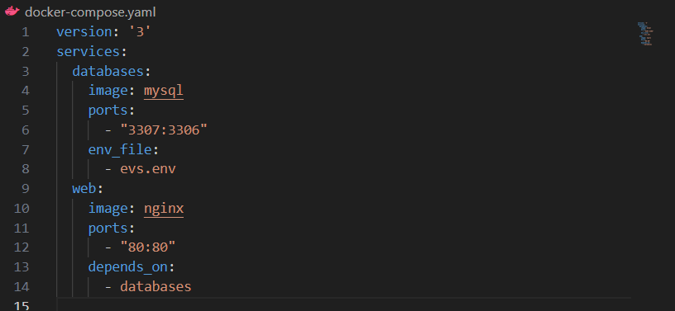

* Save docker-compose.yaml file and do docker-compose up.

docker-compose up -d

* 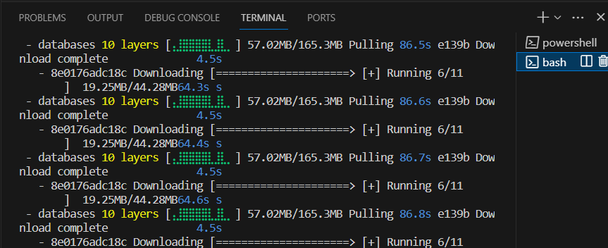
* Verify nginx service is up and is accessible on machine.

curl localhost:80

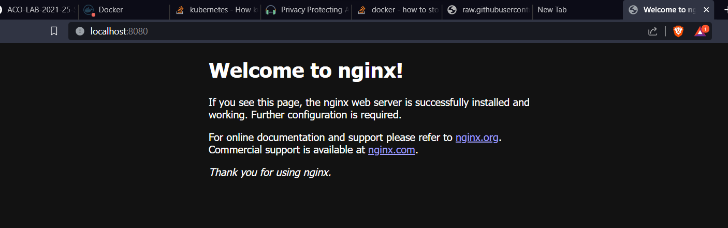

Stop and remove your docker container using docker-compose.

docker-compose down

